**PROJECT TOPIC: Heart Diseases Prediction**

**Group No: 17**

**Project Group Members:**

**Priyanshu Agrawal** (C-26/204200156)

**Prajwal Negi** (C-16/204200146)

**Rihans Jain**  (C-38/204200170)

**Sarthak Agarwal**  (C-50/204200185)

**Om Singh Raghav**  (C-10/204200140)

**Saksham Gupta**  (C-46/204200180)

**Prerak** (C-18/204200148)

**Project Supervisor:**

Mr.Atul Kumar Uttam, Assistant Professor /Associate Professor

**About the Project:**

Heart Disease detector is software which implements basic algorithms of Machine learning Program/software provides easy mechanism to check whether a human heart is functioning well of not. It considers various factors to predict the health, given in the form of dataset. Through this one can easily provide the program with the information required and can get their health checkup his/her hearth health. It will simplify the difficulty of going to doctors for the checking your heart which can cost a lot, instead with just some inputs one can do so easily

**Motivation**:

Program will reduce the headache of going to specialist to get their heart checked, especially helping those who cannot afford to get all that treatment easily.

It also reduces the extra work for the doctors, since they do not need to explicitly check the patient but with just some simple tests they can do so

**Project Planning:**

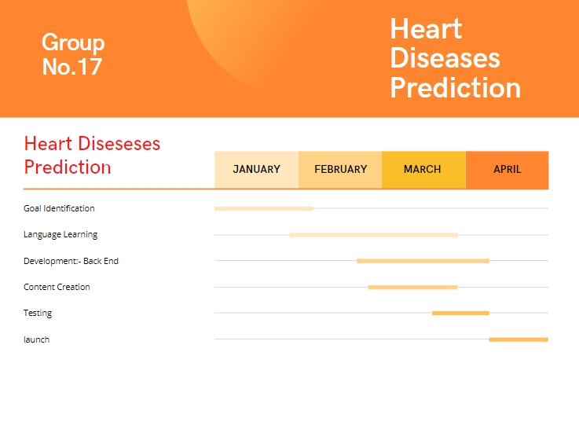

**Specifications:**

* **Hardware Requirements:**

Intel dual core or more, i3 Processor speed – 1.5GHz or above, RAM 1GB or above.

* **Software Requirements:**

Windows 7 or higher, Python installed, jupyter notebook

**Signature of Project Supervisor: _____________________**